DYLAN WILIAM
Low achievement is often the result of students failing to understand what teachers require of them. Many teachers address this issue by posting the state standard or learning objective in a prominent place at the start of the lesson, but such an approach is rarely successful because the standards are not written in student- friendly language.
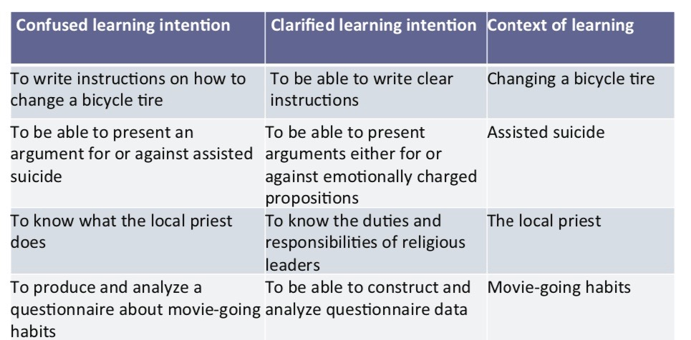
As teachers, we sometimes confuse learning objectives with learning contexts. Once we teach students something, we are not interested in students replicating exactly what we have taught them, we are interested in students applying what we have taught them. This example is clearest in mathematics. Once we have taught students how to add 3 + 5, we don’t want our students to show us that they can add 3 + 5, rather we want them to show us that they have learned the skill of addition and can apply this to a new pair of numbers.
In an HSIE lesson in which a teacher is teaching her students to understand the impact of banana production on the banana producers themselves. If students study this topic and at the end of the unit the teacher assesses the objective of whether or not the students have learned about the impact of banana production on banana producers, the students will most likely get high scores. However, this teacher has confused the learning objective with the learning context. A better and really clearer learning intention would have been for the students to understand the impact of production on producers in the developing world and banana production would have been the particular context for learning this objective. To see whether students had mastered this objective, that is, whether they could transfer their learning, the teacher should have given them an assessment on a different topic such as sugar production.
Practical Techniques
A concrete way to help students understand learning intentions and success criteria is to have them look at samples of other students’ work and discuss the strengths and weaknesses of these pieces. Teachers could construct rubrics using sample pieces of student work. One teacher, before having students write their own lab reports, distributed five sample lab reports from the previous year. In groups, students had to decide which reports were better than others and report the reasons why to the whole class. The teacher used these reasons to have the students co-construct a scoring rubric for laboratory reports. Note that this was not a democratic process. The teacher used his own knowledge to shape the discussion. By having students spot examples of errors in other students’ lab reports they were less likely to repeat these errors in their own reports.
Cautions
Use examples where deep features are not aligned with surface features. When quality has multiple dimensions, care needs to be taken that students are not able o determine which pieces are better by focusing on surface features .For example, if you are focusing on characterization, it might be useful to have one piece of work with deep characterization but poor grammar, spelling & handwriting and another with good grammar spelling and punctuation but weak characterization
Be aware that sometimes quality cannot be put into words. Perhaps the greatest danger with rubrics is that they are used where quality cannot be effectively described in words. Sometimes the best we can do is help our students develop “a nose for quality”. If the teachers build this, there is an effective basis for a high-quality assessment.
JOHN HATTIE

A starting place for lesson planning is the learning intention, or the statement of what students are expected to learn from the lesson. The learning intention for a given lesson, and the ability to communicate it clearly to students such that they can use it to gauge their progress, is foundational. Stated simply, when one knows what the target is, there is an increased likelihood that the target will be achieved. Knowing one’s learning destination is crucial.
If learning intentions serve as one bookend for learning, the other book- end consists of the criteria used to measure success. How do you know whether your students are successful at learning what you wanted them to? How do they know whether they’re successful? How can they know whether or not they’ve met the intended learning intentions, or whether they’re making progress toward doing so? With success criteria. Success criteria are statements that describe what success looks like when the learning goal is reached. They are specific, concrete, and measurable.
Effective teachers know where their students are in the learning cycle and design their instruction to foster learning. Learning intentions can include a combination of surface, deep, and/or transfer learning, with the exact combination dependent on what kinds of choices a teacher makes based on where her learners are and where she wants them to go. A teacher who fails to identify where her students are in their mathematical learning is likely to undershoot or overshoot expectations for them.
Different strategies support learning at each phase in this cycle. The first three elements of the learning cycle will incorporate surface and deep learning, while the active experimentation phase is about transfer. The daily learning intentions that are communicated by the teacher are an end product of her careful planning, as she determines the type of expected learning (surface, deep, or transfer) and how to implement instruction for that type of learning. The success criteria provide a means for students and the teacher to gauge progress toward learning, thereby making learning visible.
Learning intentions are different from syllabus outcomes. Syllabus outcomes are tough for yet-to-be- educated students to understand, and they are too broad for students to master in a single lesson. Effective teachers start with an outcome, break the learning that the outcome requires into lesson-sized chunks, and then phrase these chunks so that students will be able to understand them. Following are some examples of learning intentions that we have seen in mathematics classrooms.
- Know that a ten is really just a group of ten ones.
- Recognize that area is a specific kind of array (built from unit squares) that measures two-dimensional space, and understand why we find area by multiplying the length times the width of a rectangle.
- Learn to add two fractions with like denominators by modelling on a number line.
Learning intentions are themselves evidence of a scaffolded process that unfolds over many lessons. A key to planning a lesson is in knowing where your students currently are in their learning. It would be tough to teach students that a ten is really just a group of ten ones if they don’t understand the value of one, just as it would be difficult for students to determine growth patterns in functions if they don’t really understand what functions are or why they’re useful.
However, learning intentions can (and often should) have an inherent recursive element in that they build connections between previously learned content and new knowledge. Savvy teachers embed previous content in the new content. The teacher is not only creating a need and a purpose for students to hone learned skills, but also providing opportunities for students to experience those “aha” moments that relate concepts to a previous lesson’s content. In this way, students are continually connecting and deepening their knowledge.

BROOKHART
What Does it Mean to Share the Whole Learning Target During the Lesson?
Let’s be perfectly clear. Sharing the learning target does not mean merely writing the lesson’s objective on the board or telling the students what the objective is in a sentence or two. Most students are able to repeat back to the teacher what she said the lesson objective was, but that’s not what we mean by a shared learning target. Parroting an objective doesn’t raise student achievement; however, a lesson designed to share a whole learning target has the potential to do just that.
Teachers share a learning target with their students when they clearly describe- using words, pictures, actions or some combination of the three- in language students can understand – exactly what the students will learn during the lesson. But sharing doesn’t stop there. The entire lesson should be designed in a way that brings the learning target to life so the students can aim for it throughout the lesson and assess their progress towards it.
For example, a typical reading objective might be that students can identify the main idea in a passage of a particular type and level. That’s great for guiding the work of the teacher, but it means little from the students’ point of view. What we want is more than the students being able to say, “identify main idea”. We want students to understand that they will learn how to get a better grasp on the meaning of what they have read, why that should be a goal for them in this lesson, and how they will know what it feels like for them to do that.
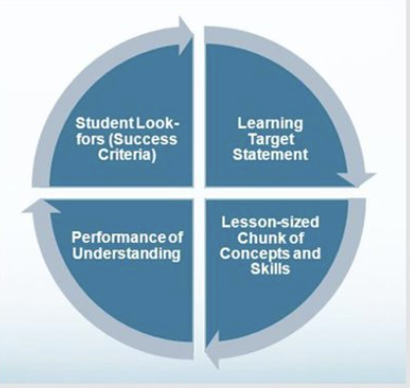
For students, this means both understanding the learning target, and knowing what good work looks like. It’s not a shared learning target if students can’t envision it, internally aim for the bull’s-eye, and help themselves get there. For this to happen, students need the whole learning target. The components of the whole learning target are illustrated in the figure attached. It includes:
- A clear learning target statement,
- A lesson-sized chunk of content that students will master to get there,
- A performance of understanding that requires students to apply their new learning and assess their own progress, and
- Student look-fors (success criteria) that enable students to assess, regulate, and improve the quality of their own learning and work while they are working.
Notice that the whole learning target requires students to actually do something to learn and improve their understanding, not just in a “hands-on” way, but by engaging in “minds-on” self-assessment and self-regulation. That’s why what we call a performance of understanding is crucial.
Sharing the whole learning target changes the dynamic of the lesson. The classroom learning team works together to continuously gather evidence of student learning. The evidence comes from what students actually do learn during the lesson. As active self-regulators, students are able to say, “If I can do this (the performance of understanding at this level of quality (the success criteria), then I will have compelling evidence that my students have mastered today’s learning target.” No single part of the whole learning target – the learning target statement, the content, the performance of understanding, or the student look -fors – is the learning target. The learning comes from the thinking and making meaning that happen when students engage with the whole learning target during the lesson.

