SEVEN PRINCIPLES OF THE INSTRUCTIONAL CORE
- Increases in student learning only occur as a consequence of improvements in the level of content, teachers’ knowledge and skill, and student engagement.
- If you change any single element of the instructional core, you have to change the other two.
- If you can’t see it in the core, it’s not there.
- Task predicts performance.
- The real accountability system is in the tasks that students are asked to do.
- We learn to do the work by doing the work, not by telling other people to do the work, not by having done the work at some time in the past, and not by hiring experts who can act as proxies for our knowledge about how to do the work.
- Description before analysis, analysis before prediction, prediction before evaluation.

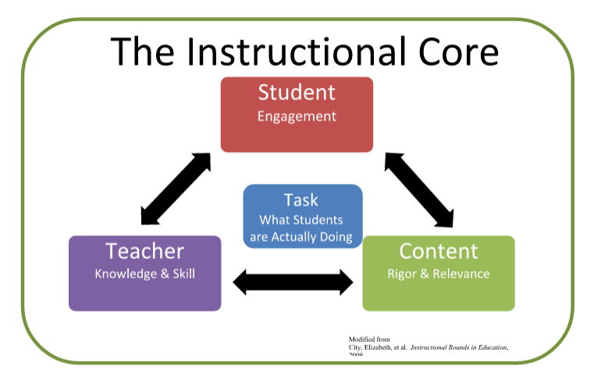

P23 Instructional Rounds in Education: A Network Approach to Improving Teaching and Learning”, City, Elmore, Fiarman & Teitel, p23

